00a- Meeting Minutes - Team

Part 1: Meeting information

Group Number | 12
Project Phase: | Sprint 2
Date/Time: | May 12, 10:00am
Type: | Team
Minute Taker: | Cole
Attendees: | Cole, Jonah, Abdullah, Nick, Kyle
Regrets: | None

Part 2 Notes:

- We assigned final sprint action items across the team, including testing, report generation, translation files, presentation preparation, and improving code comments/documentation for future handoff
- The team completed several required course activities and surveys, including peer evaluations, AI usage surveys, client project feedback, and supervisor feedback documentation
- We ran into confusion regarding whether final presentation task lists were individual or group submissions, and decided to submit individually with separate filenames to avoid issues
- The team openly discussed extensive AI usage throughout the project, with the client fully supporting the use of AI tools and modern workflows to improve development efficiency
- We finalized the structure for the final presentation, assigning each team member a feature area while planning one complete demo section at the end to keep the presentation cohesive and easier to follow
- Presentation planning emphasized improving storytelling, slide consistency, and overall flow following feedback from Sprint 1 presentations
- Current sprint work is focused on polishing major deliverables, including report generation, translation support, testing coverage, and updated test documentation
- The team agreed to sign Kyle’s remote work approval form so he can participate remotely during the final presentation period
- Overall, the team feels the relationship with the WorkSafeBC client has been very positive, supportive, and collaborative throughout the project, and most members would be open to working with them again in the future

Part 3: Action Items
Owner | Task ID (existing or NEW) | Change / New Task Summary | Risk/Issue? (Y/N)  Risk ID | Status  (Open / Closed) | Screenshot of Trello Card(s)
Cole | New - 80 | Complete surprise activity documents | N | Open | 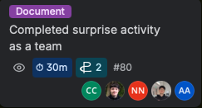

Part 1: Meeting information

Group Number | 12
Project Phase: | Sprint 2
Date/Time: | May 14, 10:00am
Type: | Team
Minute Taker: | Cole
Attendees: | Cole, Jonah, Abdullah, Nick, Kyle
Regrets: | None

Part 2 Notes:

- We assigned final development and presentation tasks across the team, with the goal of completing all coding work by the end of the day and reserving tomorrow mainly for documentation and polish
- Abdullah’s implementation work is complete and currently waiting for Geoffs feedback before merging, though a PR will still be created so progress can continue without blocking the team
- Translation development is nearly finished, with Nick expecting all remaining translations to be completed by tonight and confirming that the current translation workflow is functioning correctly
- The team discussed additional RTL layout requirements for Arabic support, including repositioning UI elements, aligning report summaries properly, and translating remaining user-facing summary text
- Cole completed the first draft of the final presentation slides, and the team divided presentation ownership by feature area to make explanations and Q&A more organized
- The presentation structure and checklist were reviewed in detail to ensure all required sections, demonstrations, and explanations are covered before the final presentation
- Team members agreed to answer presentation questions related to their own work areas, while Cole will handle broader architectural and project-level questions during Q&A
- A new ticket was added specifically for improving code documentation, since the team recognized that comments and maintainability notes are currently limited across the codebase
- Overall, the team feels development is close to completion and is now shifting focus toward presentation readiness, documentation quality, and final refinement before delivery

Part 3: Action Items
Owner | Task ID (existing or NEW) | Change / New Task Summary | Risk/Issue? (Y/N)  Risk ID | Status  (Open / Closed) | Screenshot of Trello Card(s)
Cole | New - 93 | Adding documentation throughout the codebase for easier handoff | N | Open | 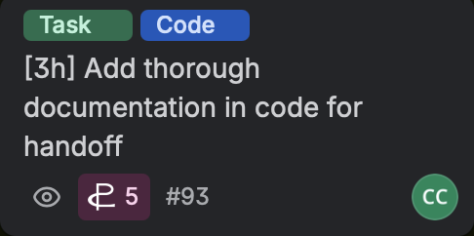

Part 1: Meeting information

Group Number | 12
Project Phase: | Sprint 2
Date/Time: | May 15, 12:00pm
Type: | Team, Retro and Sprint planning
Minute Taker: | Cole
Attendees: | Cole, Jonah, Abdullah, Nick, Kyle
Regrets: | None

Part 2 Notes:

- The team finalized the sprint goal around completing regression testing, polishing the final presentation, and preparing the short client-facing demo video deliverable
- Multiple documentation tasks were completed or nearly completed, including sprint planning, testing logs, client meeting minutes, and retrospective work, with remaining individual sections still being filled in
- A large manual regression testing task was created to verify common workflows across the application before the final presentation and client handoff
- Final cleanup tasks were identified, including removing unused Azure API key references, adding better code documentation, and improving maintainability for any future handoff to another team
- The team confirmed that the application will remain locally hosted rather than publicly deployed, which aligns with the original statement of work and project scope
- Client feedback at this stage has been very positive, with no major feature changes requested and no need to implement additional citation or sources functionality that had previously been considered
- The group discussed potentially adding links or references to job-specific resources within reports, depending on what is available in the client’s documentation and guidance materials
- One of the major lessons learned was that documentation and planning effort take far more time than initially expected, especially in a compressed four-week project timeline
- The team also recognized that high-level design discussions, estimation work, and planning activities contribute substantial value to the project even when they are not directly visible in development tickets
- Team members need to complete all remaining documentation tasks tonight, including retrospective sections, meeting minutes, Trello screenshots, and final submissions
- Everyone must record and submit their individual 60-second client demo videos while clearly referencing the sprint goal and their personal contributions
- Final technical cleanup tasks include adding code documentation/refactoring work and removing unused Azure API key references from templates and configuration files
- Manual regression testing and final verification of common app workflows remain a top priority before project delivery

Part 3: Action Items
Owner | Task ID (existing or NEW) | Change / New Task Summary | Risk/Issue? (Y/N)  Risk ID | Status  (Open / Closed) | Screenshot of Trello Card(s)
Cole | New - 120 | We need to complete a thorough regression test so we can raise any issues | N | Open | 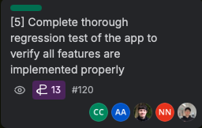
Jonah | New - 119 | Check for updates to test plan | N | Open | 